UNIVERSIDAD INTERAMERICANA DE PUERTO RICO

Recinto Metropolitano

Laboratorio Biología 1103-Destrezas I. Sección 72755

Dr. José E. Martínez Ruiz MS; PhD

Laboratory #5: Important Concepts of Elements and Molecules

Noor Hasan (M00623858)

Fecha de asignación: 24 de febrero de 2023

Fecha entrega de reporte: 7 de marzo de 2023

1. **Abstract:**

In this experiment, models of different elements and the molecules they make up were created. Those models were drawn into diagrams and used to answer questions. Elements experimented with were carbon, hydrogen, oxygen, nitrogen, phosphorus, and sulfur. Molecules included those made up of mostly carbon as well as macromolecules and functional groups. Through the study of all these different molecules, isomers were also created and used as a basis to better understand what differentiates molecules from each other.

1. **Introduction:**

This laboratory experiment studied molecules and their versatility, by building them with physical models. Through the course of the experiment, a better understanding was made of different elements and their characteristics, specifically carbon and the different bonds and structures it can form. Other important topics relevant to molecules and their structure were studied, such as isomers. Macromolecules, made up of polymers and monomers, were also studied as well as the functional groups that are apart of them. Through the course of this lab, using the lab manual and textbook, important skills for biology were practiced, such as how to write a molecular formula and draw a molecule or element accurately, as well as the different characteristics of certain element, such as mass and valence electrons. Visually, the difference in structure between certain molecules as a result of different components or bonds was understood. This information is vital in order to understand the basic composition of ourselves and the world around us.

1. **Methodology:**

This experiment was divided into 5 different activities. The first activity was on the most common elements found in living matter, specifically carbon, hydrogen, oxygen, nitrogen, phosphorous, and sulfur. The characteristics of each of these elements were determined, such as the symbol, the color each element represents in the molecular models, the atomic number, the elements mass, electron configuration, and valence electrons. This information was recorded in a table.

In the second activity, there was a focus on the element of carbon. Using the carbon and hydrogen molecular models, different molecules and their variations were created. First a molecular with 1 carbon and 4 hydrogens was created, then one with 2 carbons and 6 hydrogens, then a molecular with a double bond between 2 carbons and 4 hydrogens, as well as a molecule with a chain of 4 carbons and 8 hydrogens, another molecule with a chain of 4 carbons and 10 hydrogens. Carbon rings were also created, specifically, one made up of 5 carbons with only single bonds and 10 hydrogens, another with 6 carbons with only single bonds and 12 hydrogens, and finally a chain of 6 carbons with one double bond and 10 hydrogens. For each of these molecules a molecular drawing was made. A few questions on the difference between certain molecules due to double and single bonds and molecular formulas were answered.

The third activity of this lab was on isomers. Using 6 atoms of carbon, 12 of hydrogen, and 6 of oxygen, a molecule was created. Then, 2 other versions of this molecules were created as well, in order to make 3 isomers of one molecular formula. Questions on geometric isomers were then answered. A drawing was made for each. Using the molecular formula C2H2X2 (X being an element of our choice, and oxygen was chosen), two molecules were constructed that were geometric isomers of each other. A drawing was made for both of these molecules. The final part of this activity was to make optical isomers using 1 carbon atom and four different functional groups. A question on optical isomers was also answered.

The fourth activity focused on functional groups. The functional groups were methyl, hydroxyl, sulfhydryl, amino, carbonyl of aldehyde, carbonyl of ketone, carboxyl, and phosphate. Each of these compounds were constructed, and the structures then drawn.

The final activity was on macromolecules and their monomers. The main macromolecules are carbohydrates, lipids, and proteins. For carbohydrates, the monosaccharides D-Glucose (C6H12O6), Ribose (C5H10O5), and Deoxyribose (C5H10O4) were constructed. Their structures were then drawn. A few questions regarding these monosaccharides were answered. For disaccharides, the molecule Maltose (C12H22O11) was constructed, and a question answered on it. In regard to lipids, the saturated acidic fat called Palmitic Acid (C16H32O2) was constructed and a question on its function group answered. A no saturated acidic fat was also constructed by removing the hydrogen between the 8th and 9th carbon of the palmitic acid molecule and connecting the two carbons with a double bond. Other lipid monomers were constructed, such as Glycerol (C3H8O3) and Cholesterol (C27H46O), as well as their respective questions were answered. For proteins, an amino acid monomer called Glycine was constructed. Then a question on the functional groups of amino acids was answered as well as on an amino acid called Histidine.

1. **Results:**
2. Activity 1

|  |  |  |  |  |  |  |
| --- | --- | --- | --- | --- | --- | --- |
| **Elemento** | **Símbolo** | **Color** | **# Atómico \*** | **Número de Masa\*\*** | **Dibuja la Configuración Electrónica** | **Electrones de Valencia**  **(# enlaces que puede formar)** |
| **Carbono** | **C** | **Negro** | **6** | **12.011 u** |  | **4** |
| **Hidrógeno** | **H** | **Blanco** | **1** | **1.00784 u** |  | **1** |
| **Oxígeno** | **O** | **Rojo** | **8** | **15.999 u** |  | **6** |
| **Nitrógeno** | **N** | **Azul** | **7** | **14.0067 u** |  | **5** |
| **Fosforo** | **P** | **Naranja** | **15** | **30.9738 u** |  | **5** |
| **Azufre** | **S** | **Amarillo** | **16** | **32.065 u** |  | **6** |

1. Activity 2

|  |  |  |
| --- | --- | --- |
| **Especificaciones** | **Fórmula** | **Dibujo molecular** |
| Construye una molécula con un solo carbono y 4 hidrógenos. | CH4 |  |
| Construye una molécula con un enlace sencillo entre los 2 átomos de carbono y donde los demás enlaces sean con H. | C2H6 |  |
| Construye una molécula con un enlace doble entre 2 átomos de carbono y donde los demás enlaces sean con H. | C2H4 |  |
| Construye una molécula que contenga una cadena de 4 carbonos seguidos y donde los demás enlaces sean con el H. | C4H8 |  |
| Construye una molécula que contenga una cadena de 4 carbonos pero con una ramificación. | C4H10 |  |
| Construye una molécula que contenga un anillo de 5 carbonos con enlaces sencillos. | C5H10 |  |
| Construye una molécula que contenga un anillo de 6 carbonos con enlaces sencillos. | C6H12 |  |
| Construye una molécula que contenga un anillo de 6 carbonos con un solo enlace doble. | C6H10 |  |

1. ¿Qué para con el número de H cuando se introducen enlaces dobles?

**Cuando se añaden dobles enlaces, el número de hidrógenos disminuye, porque el carbono enlaza 2 de sus 4 electrones de valencia con otro carbono, en lugar de 1, por lo que en lugar de 3 hidrógenos solo se necesitan 2.**

1. ¿Puede una fórmula molecular representar diferentes estructuras o moléculas? Explica.

**Sí, esos se llaman isómeros. Un isómero es cuando dos moléculas están formadas por el mismo tipo y cantidad de elementos, pero debido a una diferencia en los enlaces, en el orden de los elementos o en la orientación, las moléculas tienen propiedades diferentes.**

1. Activity 3

* Isomers of C6H12O6

|  |  |  |
| --- | --- | --- |
|  |  |  |

1. ¿Cómo se conocen a las moléculas con la misma fórmula molecular y diferente conformación en el espacio? **Isómeros**
2. Explica que son los isómeros geométricos.

**Los isómeros geométricos son aquellos que tienen los mismos elementos y enlaces pero la disposición espacial es diferente. Hay isómeros geométricos cis y trans, cis es cuando los componentes están en el mismo lado y trans es cuando están en lados opuestos.**

* Isomers of C2H2X2 (C2H2O2)

|  |  |
| --- | --- |
|  |  |

* Optical isomers

|  |  |
| --- | --- |
|  |  |

1. Las manos pueden ser consideradas imágenes espejo una de la otra. ¿Cómo compara esto con tus isómeros ópticos?

**Las manos son idénticas si las pones una contra la otra y se alinean perfectamente, pero si pones una encima de la otra, no se alinearán y no parecerán idénticas. Esto funciona de la misma manera para los isómeros ópticos.**

1. Activity 4

|  |  |  |  |
| --- | --- | --- | --- |
| **Nombre del grupo funcional** | **Nombre de la molécula que la posee** | **Estructura** | **Característica** |
| **Metilo** | Compuestos metilados |  | Es estable debido al fuerte enlace de carbono e hidrógeno y relativamente poco reactivo debido a su pequeño tamaño. También es hidrofóbico y no polar. Ayudan a la estructura y función del ADN y las proteínas. |
| **Hidroxilo** | Alcohol |  | Es polar e hidrófilo, así como bueno en soluciones acuosas. Son ácidos débiles. Buen donante de enlaces de hidrógeno, utilizado para unir diferentes cadenas en muchos tipos de moléculas. |
| **Sulfidrilo** | Thiol |  | Un poco polar y tiene una baja solubilidad en agua. Conectan los aminoácidos necesarios en estructuras proteicas. |
| **Amino** | Amine |  | Necesario para construir proteínas. Se utiliza en la formación de enlaces peptídicos. |
| **Carbonilo en aldehído** | Aldehído |  | Muchos aldehídos tienen olores agradables y, en principio, se derivan de alcoholes por deshidrogenación (eliminación de hidrógeno), de cuyo proceso proviene el nombre de aldehído. Es polar y al final de la cadena de carbono. |
| **Carbonilo en cetona** | Cetona |  | Es polar y dentro de la cadena de carbono. La cetona crea acetona. Se encuentran en varios azúcares y en compuestos para uso medicinal, incluidas las hormonas esteroides naturales y sintéticas. |
| **Carboxilo** | Ácido orgánico/ácido carboxílico |  | Actúa como un ácido y pierde un protón para formar un ion cargado negativamente. Se encuentra en aminoácidos y ácidos grasos. |
| **Fosfato** | Fosfato organico |  | Es importante en la activación de proteínas para que las proteínas puedan realizar funciones particulares en las células. |

1. Activity 5

* Carbohydrates
  + Monosaccharides: D-Glucose, Ribose, Deoxyribose

|  |  |  |
| --- | --- | --- |
|  |  |  |

* 1. ¿De estas tres moléculas cual es una hexosa? **D-Glucosa**
  2. Ribosa se puede encontrar en un ácido nucleico llamado **Desoxirribonucleico**
  3. Desoxirribosa se puede encontrar en el **ADN**
  + 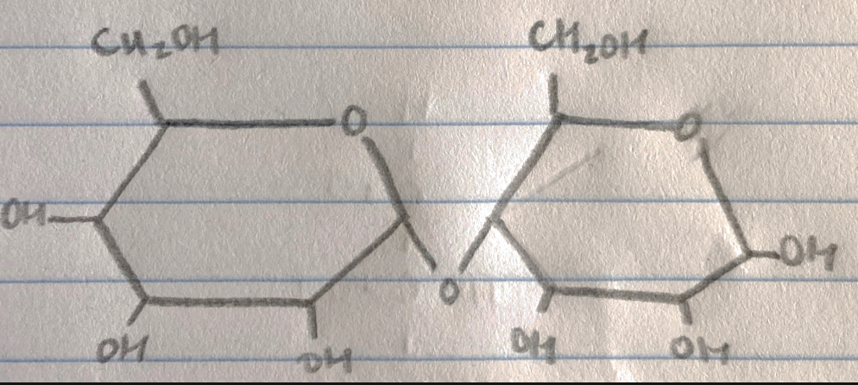Disacharides: Maltose
* Lipids
  + 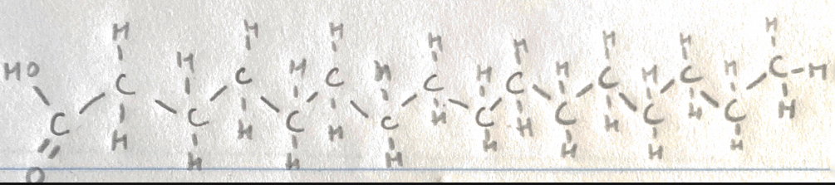Saturated acidic fat: Palmitic Acid

Su grupo funcional se llama **grupo carboxílo**

* + 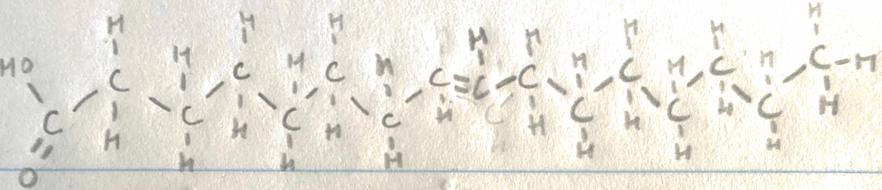Unsaturated acidic fat
  + Glycerol

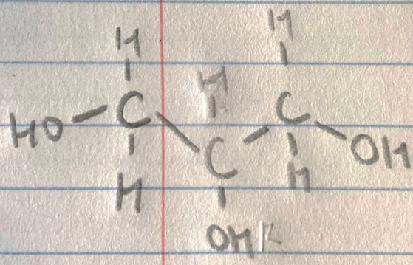

Esta molécula forma parte de otros lípidos conocidos como **saponificables** y **no saponificables**

* + 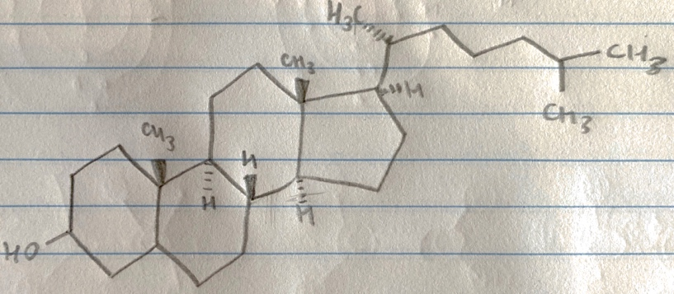Cholesterol

Este es componente de **membranas** en células animales.

* Proteins
  + 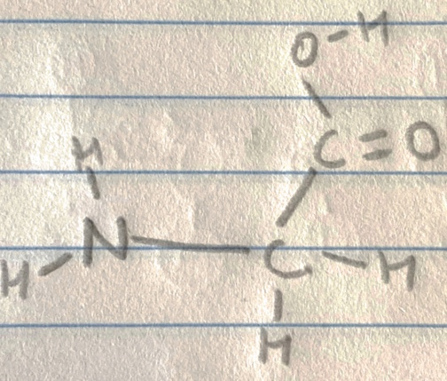Glycine

Menciona los 4 grupos que se enlazan al carbono alfa de un aminoácido.

1. Carboxilo
2. Amino
3. Hidrogeno
4. Resto lateral
   * 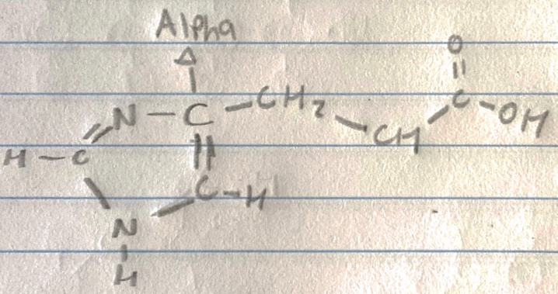Alpha carbono of Histidine
5. **Conclusion:**

With the use of molecular models, we were able to successfully understand concepts about elements, molecules, isomers, macromolecules/monomers, and functional groups. Through this lab, we are able to gain a better understanding on vital elements such as carbon, oxygen, nitrogen, hydrogen, phosphorus, and sulfur, as well as their important characteristics, specifically valence electrons, mass, and atomic number. With the activities of this lab, we were able to study in specific carbon, a necessary element in organic material. The topic of double and single bonds was applied to carbon, as well as the many shapes a carbon molecule can take, like a chain or ring shape. Diving into the topic of molecules, we examined different types of isomers, such as geometric and optical, and with the use of examples, were able to visually learn. Another important topic covered in the lab was functional groups, their structures and characteristics being focused on. Finally, important macromolecules and their monomers were studied, applying all that was learned on different bonds and molecular shapes.

1. **Post-Lab Questions**
2. ¿Cómo se les conoce a los compuestos que contienen carbono?

**Compuestos orgánicos.**

1. ¿Cuántos enlaces pueden formar los elementos siguientes?

a. Carbono: **4**

b. Oxígeno: **2**

c. Hidrógeno: **1**

d. Azufre: **6**

e. Nitrógeno: **3**

f. Fósforo: **5**

1. Menciona algunos compuestos orgánicos
   1. **Carbohidratos**
   2. **Lípidos**
   3. **Proteína**
   4. **Ácidos nucleicos**
2. Escribe la fórmula química para los siguientes grupos funcionales:

Grupo hidroxilo- **OH**

Grupo carbonilo- **C=O**

Grupo carboxilo- **COOH**

Grupo amino- **NH2**

Grupo sulfidrilo- **SH**

Grupo fosfato- **OPO3^2-**

1. Menciona los 4 tipos de macromoléculas en los seres vivos.
   1. **Carbohidratos**
   2. **Lípidos**
   3. **Proteína**
   4. **Ácidos nucleicos**
2. Menciona los tres tipos de carbohidratos.

**Azúcares, almidones y fibra.**

1. Menciona 5 funciones de las proteínas
   1. **Enzima**
   2. **Mensajera**
   3. **Anticuerpo**
   4. **Estructural**
   5. **Transporte**
2. ¿Cuáles son los 4 componentes que rodean al carbono central alfa en un aminoácido?

a**. Grupo amino** c. **Grupo carboxilo**

b. **Átomo de hidrógeno** d. **Grupo R**

1. ¿Cómo se forma un enlace peptídico? Ilustra.

**Los enlaces peptídicos ocurren cuando el carbono de un grupo carboxilo y el nitrógeno de un grupo amino se unen.**

1. Compara el DNA y RNA en cuanto a su localización, función y estructura.

|  |  |  |  |  |
| --- | --- | --- | --- | --- |
|  | **Nombre del azúcar** | **Bases** | **Lugar donde encontramos** | **Función** |
| **DNA** | **Desoxirribosa** | **Adenina, guanina, timina o citosina** | **En el núcleo de una célula** | **Contiene el material genético necesario para la vida.** |
| **RNA** | **Ribosa** | **Adenina, guanina, uracilo o citosina** | **En el citoplasma de una célula** | **Ayuda a transferir el código genético necesario para la creación de proteínas desde el núcleo hasta el ribosoma.** |

1. **References:**

Martínez Ruiz J. 2017. Manual de Laboratorio Biología 1103: Laboratorio de Destrezas Biología I. <https://interbb.blackboard.com/webapps/blackboard/execute/content/file?cmd=view&content_id=_24423073_1&course_id=_383558_1&framesetWrapped=true>

Urry, Cain, Wasserman, Minorsky, Orr. Campbell Biology in Focus. Third edition. Pearson’s.